The Global Water Cycle [ANSWER KEY]

- Lakes and Streams  - Glaciers  - Runoff  - Groundwater | - Condensation  - Transpiration  - Sublimation  - Evaporation | - Oceans  - Atmosphere  - Precipitation  - Infiltration (percolation)
Water is stored in 5 places on Earth. Name each place and note the phase that water is in (i.e., liquid, solid, or gas).
Place | Phase?
1) Lakes and Streams | Liquid (water)
2) Glaciers | Solid (ice)
3) Groundwater | Liquid (water)
4) Oceans | Liquid (water)
5) Atmosphere | Gas (vapor)

There are 7 processes involved in the water cycle. Name and define each process. Include the phase change that water goes through during each process.

Process | Definition | Water phase? | Place?
1) Runoff | Precipitation runs over land into a water body | Liquid → Liquid | Any area adjacent to a water body
2) Condensation | Water vapor turns into liquid water | Gas → Liquid | Atmosphere
3) Transpiration | Loss of water vapor from plants | Liquid → Gas | Plant surfaces, atmosphere
4) Sublimation | The conversion of snow or ice directly into water vapor | Solid → Gas | Glaciers and Icecaps
5) Evaporation | The conversion of liquid water into water vapor | Liquid → Gas | Surface of water bodies
6) Precipitation | The condensation of water vapor into liquid water droplets | Gas → Liquid | Atmosphere
7) Infiltration | Water that is absorbed into the Earth | Liquid → Liquid | Land
2

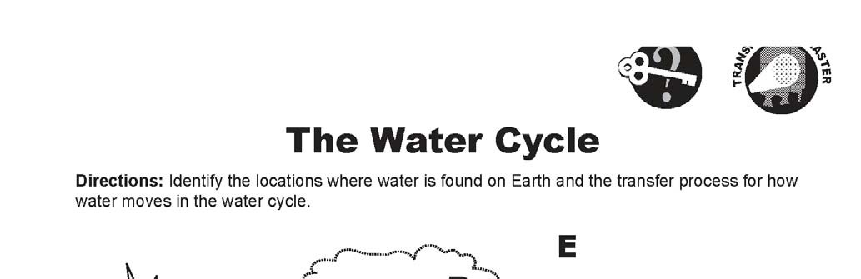
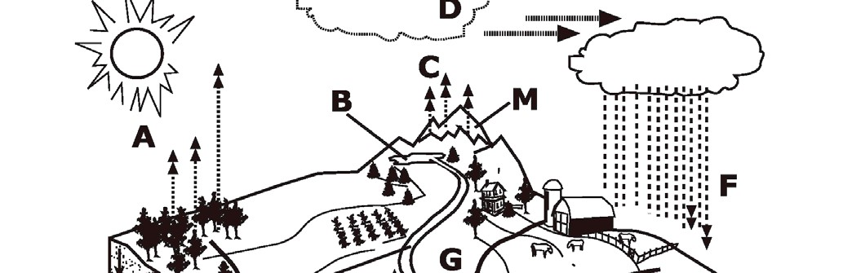
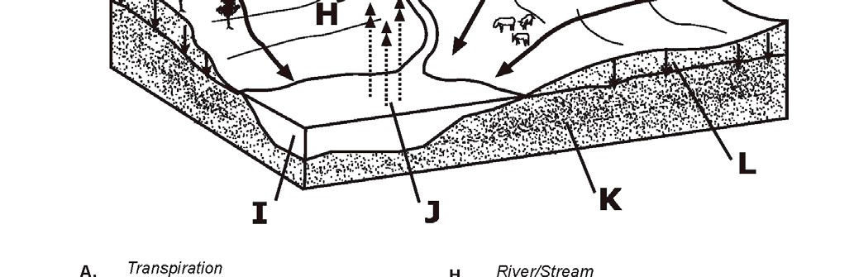
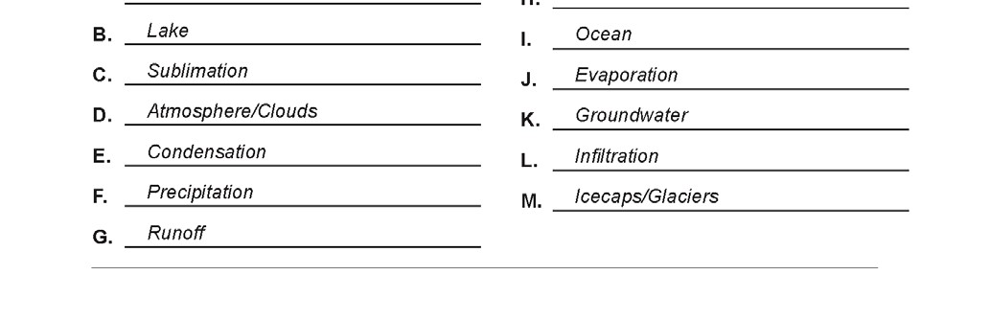
2

